Relational and Behaviour Policy

School Mission Statement
At Garstang Community Primary School we treasure each and every one of our pupils. We create inspirational learning opportunities in a vibrant, supportive environment in which our pupils grow together and are excited about their future in an ever changing world.
Aims
• We recognise the individuality of each of our pupils and nurture them emotionally, socially, spiritually, morally and culturally.
• We create inspirational learning opportunities within an exciting curriculum which equips our pupils with the skills and knowledge needed to be successful in a dynamic world.
• Our pupils become enterprising, inquisitive young people with high expectations of themselves and a lifelong love of learning.
• We develop strong partnerships with parents, creating an atmosphere of mutual trust, and working together to provide the very best for our pupils.
• We create opportunities for our pupils to be active participants in the local and global communities and to develop an understanding of their place in the world.


Policy created: September 2024
Review date: September 2026

Date Reviewed | Changes made | Initials
8th April 2025 | Inclusion of Seedlings@GCP Nursery | SR
September 2025 | Review -no changes required | SR
August 2026 | Additions to Restrictive Intervention and Seclusion section with regard to the guidance issued April 2026 | SR

Policy Statement

At Garstang Community Primary School, everyone is expected to maintain the highest standards of behaviour, accept responsibility for their behaviour, and encourage others to do the same. We believe that understanding our emotions is a key aspect of understanding and managing behaviour. We create an environment where both children and adults are able to manage their behaviour and where everyone feels safe and is able to learn. Garstang Community Primary School is committed to supporting the mental health and wellbeing of its staff, pupils and parents/carers. This policy demonstrates our belief that everyone can learn to self-regulate their own emotions and behaviour. Through our policy we encourage children to make good choices, give them the confidence and capacity to think for themselves and to make sense of their own lives and experiences, in school, in the community and in their later lives.

Policy Aims

- To build a community that values kindness, care, unconditional respect, good humour, and empathy for others
- To create a culture of exceptionally good behaviour
- To promote respectful and rewarding relationships
- To help pupils take responsibility for, and control over, their behaviour.
- To encourage children to become emotionally aware, and develop a clear sense of worth, identity and achievement
- To promote, teach and support emotional regulation and positive mental health of the whole school community.
- To develop in all children the ability to listen to others; cooperate and to appreciate other ways of thinking and behaving.
- To support children to become responsible, independent and positive members of society
- To maintain an effective learning environment for all.

Roles and Responsibilities

Staff

- Always lead by example, treating everyone with kindness and respect, maintaining the highest standard in their own behaviour
- Meet and Greet children each day and accompany children out at the end of each day
- Explicitly teach children how to make good choices and redirect them where necessary
- Always pick up on children who are failing to meet expectations
- Have clear and consistent routines and expectations in class and around school, including assemblies, lining up and in the dinner hall
- Ensure work is engaging and adapted to meet all children’s needs
- Use calm, positive voices, avoiding raised voices at all times
- Attend training to support effective behaviour management, and put learned strategies in place
- Have a good understanding of the needs of all of the children in their care, showing awareness of the impact of SEND, ACES and attachment issues.

SLT

- As above, and:
- Be a visible presence around school, in classrooms, hall and playground
- Encourage the use of positive language and actively support the use of motivational rewards
- Ensure staff training needs are identified and met
- Ensure staff are aware of the individual needs of children with challenging behaviours
- Monitor entries on CPOMs and action where needed. Monitor trends in cohorts, groups and individuals
- Support staff in managing children with more complex or challenging behaviours.

SENCO

- Support staff dealing with challenging behaviour in writing plans, risk assessments and signposting to resources
- Identify training and support that staff need
- Monitor entries on CPOMs for identified children and action where needed
- Complete referral paperwork where necessary, in conjunction with SLT.

Governors

- Understand and support the policy and practices, ensuring they are effective
- Support the mental and emotional well-being of all stakeholders

Pupils

- Keep themselves and others safe
- Be respectful of themselves, others, and their environment
- Build and sustain healthy, happy relationships
- Understand how to use restorative approaches to repair harm and restore relationships.

Parents/Carers

- Work in partnership with school to ensure the best outcomes for their children
- Be respectful of themselves and others
- Be positive role models for their children, supporting their own emotional well being and their child’s emotional development
- Be ready to greet children at the end of the school day with positivity
- Use social media responsibly and respectfully, and report any concerns directly to the school

Whole School Systems and Expectations

Our behaviour expectations can be grouped under three headings:

Ready to Learn
- We are the best that we can be and are always ready to learn
- We work hard and go ‘above and beyond’

Respectful
- We respect ourselves and others, in person and online
- We behave in a way that allows everyone to learn

Safe
- We play safe and friendly games
- We use kind words, hands and feet

The school expectations are discussed regularly with children in assemblies, in class, and are displayed in every classroom and across the school.

The expectations are reinforced through positive recognition of the excellent behaviour seen throughout the day within school. At Garstang Community Primary School, the following strategies are implemented consistently across school to promote good behaviour and to maintain strong relationships:

- Acknowledgement of expected behaviour and actions through positive praise
- Use of dojos for demonstrating good behaviour and following school and class expectations
- Team points for excellent work
- Weekly Celebration Assemblies where each class choose a Class Star (for showing good citizenship skills) and Learning Hero (for showing good learning behaviours). An overall Superstar is also chosen by the Headteacher for a child who goes ‘above and beyond’. Out of school achievements are also celebrated, to further strengthen relationships. Parents are invited to this assembly.
- Pupil sent to Headteacher for outstanding behaviour or work to receive a special HT sticker

Consistency

Children thrive on consistent behaviour management techniques; although we do understand that teachers have their own strengths and autonomy within classrooms. We also acknowledge that all members of the school community may have different lived experiences and views on behaviour. However the aim of our Relational and Behaviour Policy is to bring us all together to adhere to the same basic principles and practices that reflect our school ethos. The following non-negotiables will be displayed by all members of staff in our school:

- We are careful what we say and how we say it
- We are respectful and non-judgemental
- We use positive language, where appropriate saying what should be done rather than what shouldn’t (eg ‘we walk in school’ rather than ‘stop running’)
- Voices remain calm and in control
- Language is kept to a minimum when a child is in fight or flight
- Adults are aware of their body language and use appropriate non-verbal cues.
- Language shows empathy towards a child
- Our language engages pupils in learning about the effects of their actions making sure the reason for a decision is always understood
- We set clear expectations for the future
- Restorative approaches are used to help pupils understand the effect of their actions and the importance of taking responsibility to make things right. See appendix 2a/b for agreed approaches.

Managing Behaviour in Classrooms

At Garstang Community Primary School, we believe that building positive relationships, and creating safe, nurturing environments is key to fostering good behaviour. Relationships are central to our sense of belonging and a secure environment is conducive to engagement and learning. Within our classrooms we create safe and nurturing environments where behaviour is exceptional and learning can take place.

Within classrooms, staff will use a range of strategies to promote and maintain exceptional behaviour. These may include a range of the following:

- Fostering a genuine rapport and connection with all individuals within the class
- Make expectations explicit to pupils and refer to them regularly. There will be consistency in enforcing the expectations
- Actively catch the children following expectations and acknowledging it with praise
- Praise individuals as well as the whole class
- Use of dojos/team points
- Display and insist on SLANT (Sit up straight, Look and listen, Ask and answer questions, Nothing in hands, Track the speaker)
- Be well-prepared with appropriately pitched lessons, with all appropriate resources ready prior to the start of the lesson
- Expect high standards of work and presentation
- Only starting a lesson, or talking to the class, when all pupils are paying attention
- Be firm but fair
- Not accepting low-level disruption/poor behaviour
- Using verbal prompts to maintain on-task behaviour during lessons
- Using time prompts for pieces of work to ensure pace
- Not being drawn into an argument with a child, or give them an audience
- Allowing a child to explain their behaviour at an appropriate time and place (this will mostly not be in front of the class) using restorative questions to guide the conversation and ensure fair process
- Ensuring pupils understand they are responsible for their actions, to accept consequences and restore relationships
- Demonstrating respectful behaviours between staff and towards pupils at all times
- Proactively identifying possible difficulties in advance and implement strategies to diffuse the situation.

In the event of behaviours not reaching the required standard, the following graduated response will be implemented by the teacher in charge:

- Reminder

A reminder of the expectations for pupils delivered privately to the learner. The teacher makes them aware of their behaviour. The learner has a choice to do the right thing.

- The Caution

A clear verbal caution delivered as privately as possible to the learner making them aware of their behaviour and clearly outlining the choices the child might make. The learner has a choice to do the right thing. Learners are reminded of their previous good conduct to prove that they can make good choices. We resist endless discussions around behaviour and spend our energy returning pupils to their learning.

- Time-out zone in classroom/resource area (dependent on age)

The teacher will speak to the child away from others. Boundaries are reset, (if needed) and the pupil will be asked to reflect on their next step. A short time limit will be given (age dependent and no more than 10 minutes) and then the child will be given a final opportunity to re-engage with the learning / follow instructions. Staff will always deliver sanctions calmly and with care. It is in nobody’s interest to confront poor behaviour with anger. Once the time is finished it is important to have a restorative conversation before the child joins back in with their peers and learning. If this is in the middle of a session, then the discussion should take place at the next break.

- Consequence and Repair

A restorative conversation will to take place. These are structured using the relevant system dependent on age/understanding of the child (see Appendix 2a/b ). Whatever has gone wrong will be put right (e.g. completing work, apology given to adult or child, fixing, tidying). Parents may be informed, dependent on severity of behaviours.

This step may be entered onto the CPOM system at teacher’s discretion.

- Intervention from member of SLT

If Steps 1-4 are unsuccessful, or in cases of children showing violence, unsafe or inappropriate actions or language, staff will call on the SLT to assist. SLT will decide on consequences, dependent on behaviours. This may include a short internal exclusion, where the child will work in the Headteacher’s office. Parents will be informed.

This step must be entered onto the CPOM system.

Children must never be left unsupervised. If the consequence is to miss a break time, a member of staff must be with the child in the classroom. The child must still be afforded welfare rights such as toileting, snack and drinks. Children must never be put in the school foyer as a consequence of their behaviours.

Managing Behaviour on the Playground

Break time is an important aspect of maintaining physical and emotional wellbeing. Breaktimes at Garstang Community Primary School are usually harmonious and give children the opportunity to mix with children outside of their classroom environment. It is a time for children to enjoy physical activity and each other’s company. However, due to the more unstructured and busy nature of the playground, incidents can and do occur.

Children who do not show expected behaviour on the playground will be initially reminded about expected behaviours. Restorative action may be needed (eg an apology to another child) Following this, if the behaviour is not corrected, they will be directed to stand next to an adult who is on duty. This is the child’s opportunity to reflect and adjust their behaviour. This should be for a set period of time (eg five minutes). If, on returning to play, the behaviour continues, the class teacher or, at lunchtime, the member of SLT on duty will be informed immediately and suitable consequences could include:
- Missed playtimes
- Not being allowed to participate in timetabled playground activity
- Earning the right to go back onto the playground

If violent or aggressive behaviour occurs, a member of the SLT will be sent for immediately. The child will be asked to leave the playground and follow the member of SLT to the Headteacher’s office. A restorative conversation will take place following the guidance outlined in this document. (Appendix 2a/b)

Serious Incidents

All serious behaviour matters must be referred immediately to the Headteacher or SLT. Such incidents could include:

• Fighting
• All forms of bullying
• Racist, sexist or homophobic comments
• Inappropriate name calling
• Using abusive/offensive language
• Physically harming adults/pupils

Suspensions/Exclusions

Suspensions

Garstang Community Primary School believes that, in general, suspensions are not an effective means of moving behaviour forward. However, in order for children to achieve their maximum academic potential in the school they must feel safe from physical and verbal aggression and disruption. If a child seriously breaches the school’s behaviour policy and if the pupil remaining in school would seriously harm the education or welfare of others in the school, the Headteacher may take the decision to suspend for a fixed period. If this decision is taken, work will be set for the pupil to complete at home. Following suspension the pupil and parents must meet the Headteacher to discuss the pupil’s reintegration to school and the best way forward to support the child. Each day is a new day and where a child has transgressed it is expected that they will be welcomed back and treated without any resentment when they return.

Permanent Exclusion

The Secretary of State for Education feels that permanent exclusion should be seen as a last resort and that a school should be able to show that it has taken all reasonable steps to avoid exclusion (See Exclusion Regulations). The governors of Garstang Community Primary School agree with this stance and all policies and procedures are in place to support inclusion of all pupils. Permanent exclusion should only occur when risk assessment indicates that to allow the child to remain in school would be seriously detrimental to the education or welfare of the pupil concerned, or to others at the school.

Recognising the impact of SEND on behaviour.

Garstang Community Primary School recognises that pupils’ behaviours may be impacted by a special educational need or disability (SEND). When incidents of misbehaviours arise, we will consider them in relation to a pupil’s SEND, although we recognise that not every incident of misbehaviours will be connected to their SEND. Decisions on whether a pupil’s SEND had an impact on an incident of misbehaviour will be made on a case-by-case basis. When dealing with misbehaviour from pupils with SEND, especially where their SEND affects their behaviour, the school will balance their legal duties when making decisions about enforcing the behaviour policy and keeping the pupil and others in school safe.

The legal duties include:
• Taking reasonable steps to avoid causing any substantial disadvantage to a disabled pupil caused by the school’s policies or practices (Equality Act 2010)
• Using our best endeavours to meet the needs of pupils with SEND (Children and Families Act 2014)
• If a pupil has an education, health and care (EHC) plan, the provisions set out in that plan must be secured and the school must co-operate with the local authority and other bodies. As part of meeting these duties, the school will anticipate, as far as possible, all likely triggers of misbehaviour, and put in place support to prevent these from occurring. Any preventative measures will take into account the specific circumstances and requirements of the pupil concerned. These may include:
• Short, planned movement breaks for a pupil with SEND who finds it difficult to sit still for long
• Adjusting seating plans to allow a pupil with visual or hearing impairment to sit in sight of the teacher
• Training for staff in understanding conditions such as autism
• Use of calm spaces where pupils can regulate their emotions during a moment of sensory overload

The Use of Reasonable Force

Reasonable force can be used but is usually as a last resort and only used to ensure pupil and/or staff safety. Staff should always consider whether there are other more effective, less restrictive ways to manage a situation. Staff should assess whether a restrictive intervention is likely to successfully reduce the risks or whether its use would escalate the situation further or cause more harm than the behaviour itself. It may be used to prevent a pupil from doing, or continuing to do, any of the following:-
• Committing a criminal offence.
• Injuring themselves or others.
• Causing damage to property (including the pupil’s own property).
• Engaging in any behaviour prejudicial to maintaining good order and discipline.

There are a wide variety of situations in which reasonable force might be appropriate, or necessary:
• A pupil attacks a member of staff, or another pupil
• Pupils are fighting
• A pupil is engaged in, or is on the verge of committing deliberate damage or vandalism to property
•A pupil is, or is at risk of, causing injury or damage by accident by rough play, or by misuse of materials
• A pupil running in a corridor or stairway in a way in which they might cause an accident
• A pupil absconds from a class or tries to leave the school
• A pupil persistently refuses to obey an order to leave a classroom
• A pupil is behaving in a way that is seriously disrupting a lesson

The use of reasonable force is never used as a substitute for good behavioural management. Throughout the process it is important to try to diffuse the situation by using some or all of these methods:-
• Using a calm voice
• Isolating the area so that there is no audience
• Bringing in a second member of staff
• Offering alternatives to behaviour e.g. “You can do this or you can do that but you cannot continue to do what you are doing.”

If physical intervention is necessary, the following principles apply: -
• The pupils will be warned verbally that physical restraint will be used
• Minimum force only will be applied
• Every effort to secure the presence of other staff will be made
• Restraint will be an act of care and control, not punishment
• Acts of restraint will be carried out in a firm and calm manner without being aggressive towards pupils
• Staff should seek to maintain respect for a pupil’s dignity
• If the intervention itself is escalating the situation, staff should reconsider their approach and attempt an alternative strategy.
• Seclusion – a non-disciplinary intervention involving keeping a pupil confined to a place away from others and prevented from leaving – should only be used as a safety measure to protect others from harm when a pupil is experiencing high levels of emotional or behavioural dysregulation. If seclusion is necessary, the place to which the pupil is confined should be safe and not feel threatening or intimidating to the pupil. The pupil should be supervised at ll times during the period of seclusion. As soon as the immediate risk of harm has reduced, the pupil should be allowed to leave.
• Following incidents, the removing teacher takes the pupil to a quiet place and interviews the pupil to allow him/her to speak about the incident, when both the pupil and staff member are in a calm state of mind. The pupil is made aware of the seriousness of the incident and what will happen next.
Recording and Reporting the Use of Restrictive Interventions and Seclusion

The use of restrictive interventions and seclusion will be reported to the SLT using CPOMS. Staff will record the following details as a minimum:
• names of pupil and staff directly involved
• any relevant needs or circumstances of the pupil, including whether the pupil involved has an identified special educational need or disability and their SEN status code
• time, date, location and approximate duration of the intervention
• brief account of the incident, including what led up to the incident, identified or potential triggers if known, any preventative or de-escalation strategies used, and (where relevant) what type of reasonable force was applied, the degree of force, and details of any physical injuries sustained
• brief account of why the use of force was assessed as necessary in that instance
• any post-incident support, such as details of any medical treatment for injuries or other adverse impacts

A report of the incident will be made to parents by a member of the SLT and will include the following details as a minimum:
• time, date, location and approximate duration of the intervention
• brief account of why the intervention was assessed as necessary in that instance
• brief account of what type of force was applied, and the degree of force
• details of any physical injuries sustained, if applicable

The requirement to report applies even if the use of restrictive interventions in certain circumstances is agreed with parents as part of a pupil’s behaviour support plan. SLT will communicate this information to parents in writing. Best practice would include inviting parents to have a follow-up discussion about the incident where appropriate. This will involve a discussion about:
• any behavioural triggers or warning signs of an impending incident
• whether any agreed behaviour support plans were followed
• what de-escalation strategies were used and how effective they were
• what might be done differently in the future

The school may use this information to amend any existing behaviour support plans, as needed.

Beyond the School Gate

Whilst this behaviour policy refers mainly to the behaviours of pupils within school premises, the school reserve the right to discipline beyond the school gate.
Our policy covers any inappropriate behaviour when children are:
• taking part in any school organised or school related activity
• travelling to or from school
• wearing school uniform
• in some way identifiable as a pupil from our school
• poses a threat to another pupil or member of the public
• could adversely affect the reputation of the school
In the incidences above, the headteacher may notify the police of any actions taken against a pupil. If the behaviour is criminal or causes threat to a member of the public, the police will always be informed.

Out of School Behaviour

The school is committed to ensuring our pupils act as positive ambassadors for us. Taking the above into account, we expect the following:
• Good behaviour to and from school, on educational visits or during learning opportunities in other schools.
• Positive behaviour which does not threaten the health, safety or welfare of our pupils, staff, volunteers or members of the public.
• Reassurance to members of the public about school care and control over pupils in order to protect the reputation of the school.
• Protection for individual staff and pupils from harmful conduct by pupils of the school when not on the school site.
The same behaviour expectations for pupils on the school premises apply to off-site behaviour. When there is a case of poor pupil behaviour beyond the school gate (travelling to or from school, taking part in any school organised or school related activity, wearing school uniform or in some way identifiable as a pupil at the school), the school may enforce its right to apply a consequence to a pupil in school. Examples of this may include:
• continued bullying of a pupil outside of school
• use of cyber bullying/Artificial Intelligence to bully outside of school
• inappropriate behaviour taking place close to the start/end of day when pupils are in school uniform (including at breakfast/afterschool club)
• behaviour that poses a threat to another pupil or member of the public
• behaviour that could have repercussions for the orderly running of the school
• behaviour that could adversely affect the reputation of the school

Sanctions and Disciplinary Action – Off-Site Behaviour
Sanctions may be given for poor behaviour off the school premises which undermines any of the above expectations and regardless of whether or not it is an activity supervised directly by school staff. Sanctions may be in the form of withdrawal of privileges, suspension or in very serious cases, permanent exclusion. In issuing sanctions, the following will be taken into account:
• The severity of the misbehaviour.
• The extent to which the reputation of the school has been affected.
• Whether pupils were directly identifiable as being a member of our school.
• The extent to which the behaviour in question could have repercussions for the orderly running of the school and/or might pose a threat to another pupil or member of staff (e.g. bullying another pupil or insulting a member of staff).
• Whether the misbehaviour was whilst the pupil was taking part in learning opportunities in another school, participating in a sports event (and in any situation where the pupil is acting as an ambassador for the school) which might affect the chances or opportunities being offered to other pupils in the future.
Application
This Behaviour Policy is for all our school community. If it is to be effective, everyone must use it with confidence and consistency.

Seedlings@GCP Nursery

The areas listed in this policy apply to the main school. Below is information specifically for the EYFS in nursery and in transition to school (generally the first half term):
Seedlings@GCP Nursery aims to create a caring learning environment. We believe that in order to enable an effective learning environment in which children can develop socially, emotionally and academically, good behaviour in all aspects of nursery life is necessary.
We seek to create a caring learning environment for all children by:
- Encouraging and acknowledging good behaviour and having a consistent approach to unwanted behaviour
- Promoting self-esteem by encouraging children to value and respect themselves and others
- Providing a safe environment
- Promoting early intervention
- Encouraging a positive relationship with parents/carers
- Encouraging children to take responsibility for their behaviour
- Explaining unacceptable behaviour
- Being good role models

Encouraging good behaviour
Positive behaviour is promoted through:
  - Praise, rewards and encouragement, e.g. smiles, stickers, positive language
  - Using it as an example to others to promote desired behaviour
  - Modelling and developing social skills such as: sharing, manners, hygiene and taking turns
  - Encouraging children to take responsibility for their own behaviour and that of others, e.g. supporting a child to tell another child ‘please don’t do that, I don’t like it’.
Dealing with undesirable behaviour
Our starting point is to consider the child’s age and stage of development. Unacceptable behaviour includes:
  - Bad language and derogatory language
  - Not complying with turn taking sharing and other social skills
  - Physical harm of the other children/self or staff
  - Repetitive damage of nursery property or of that belonging to another child
  - Bullying
Staff will work prevent unwanted situations occurring by intervening before they happen.
We have a variety of strategies that we use to deal with unwanted behaviour. These vary according to the age and stage of the child, the situation and other factors such as tiredness.
These include:
  - Reminders
  - Verbal warnings with explanation
  - Removal of equipment
  - Distraction
  - Removing of child from situation
  - Time out (as appropriate)
However, our focus is always on promoting positive behaviour and the prevention of unwanted behaviours.
If a child is showing persistent behaviours that are not typical to their age/stage we will then take the following steps:
  - Persistent behavioural problems will be discussed with the parent/carer, noted in the child’s records and the SLT will be informed
  - If necessary, an individual behaviour plan will be implemented
  - Further advice from partnership agencies will be sought if necessary i.e. health visitor, community nursery nurse, speech and language team, EP etc

Appendix 1
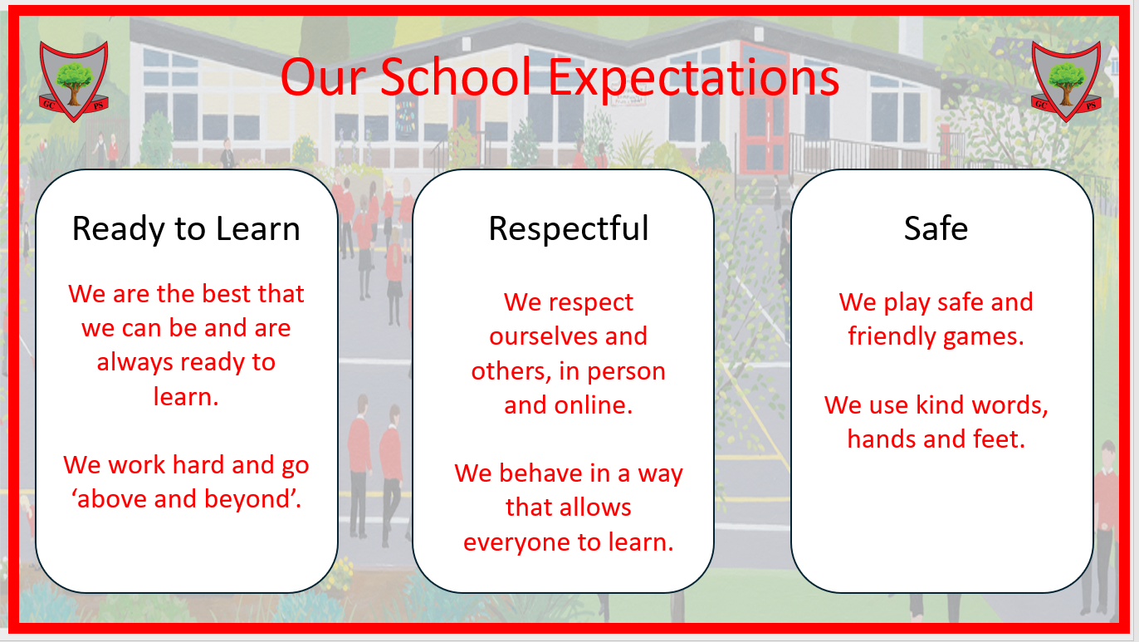

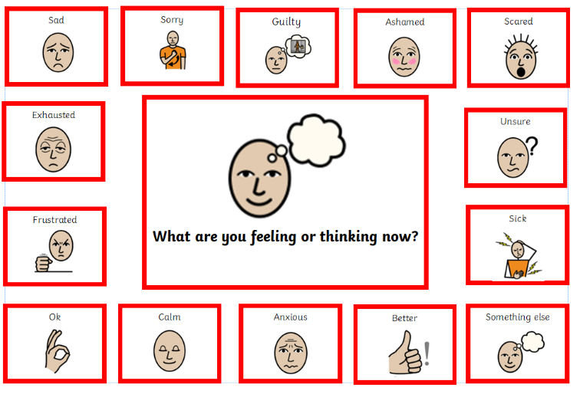
Appendix 2a
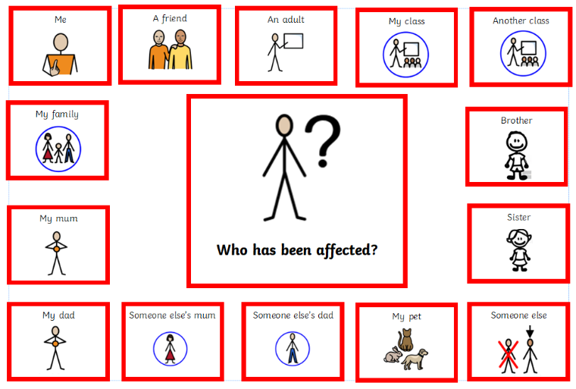
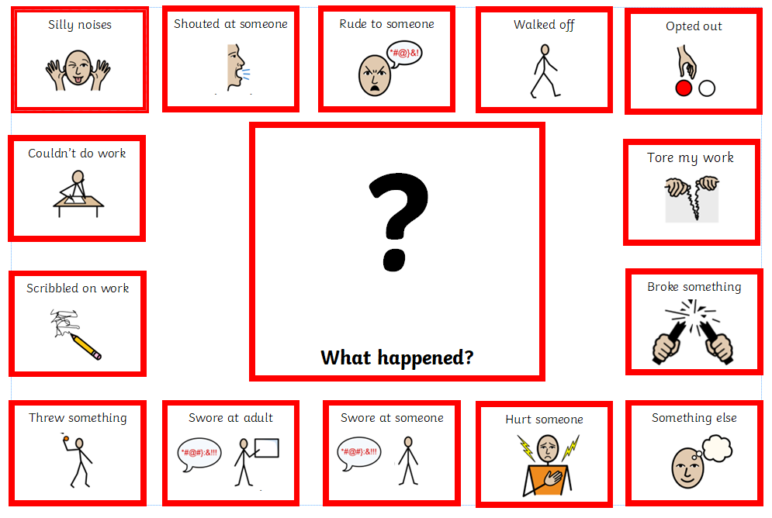
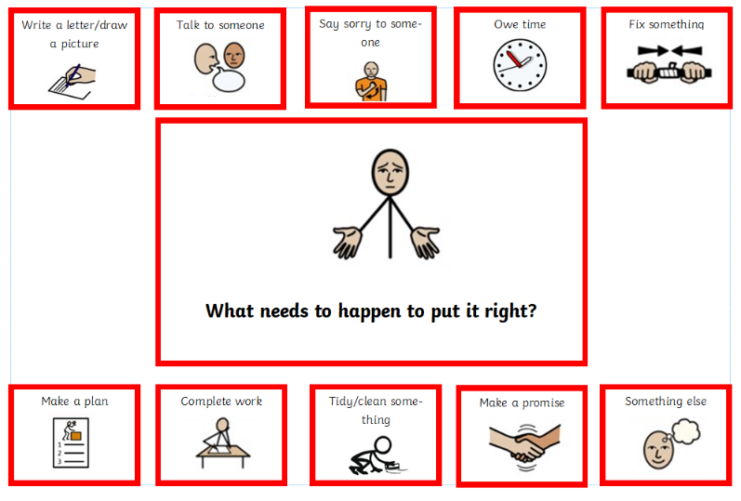
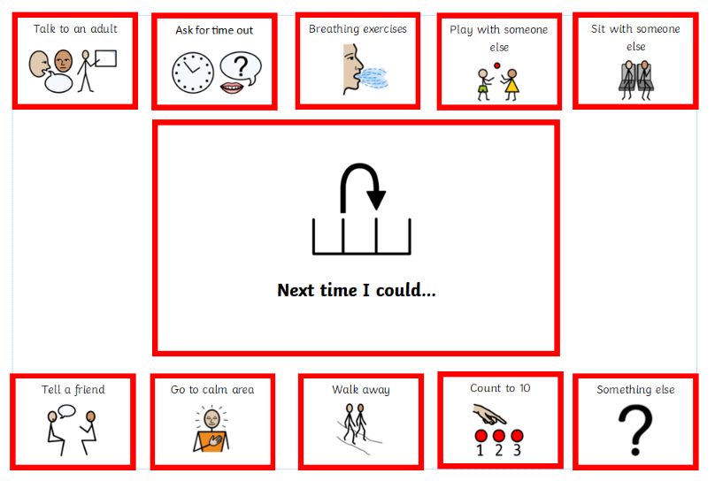

Appendix 2b

Restore, Redraw, Repair
- What happened?
- How did that make you feel?
- How do you think did that made *** feel?
- What could you do that is different next time?
- What do you think should happen next to help repair this?

Appendix 3

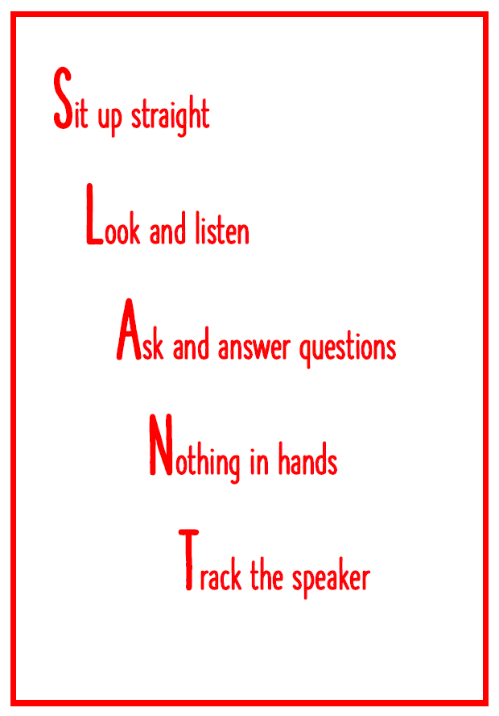

Appendix 4 – Classroom Behaviour - Copy for display
Reminder   | I will be given a reminder of the  expectations.  I will then show the expected behaviour.
Caution   | I will be reminded about my choices.  I will make a good choice.
Time Out   | I will spend time in the area, thinking about the choices I have made.  I will discuss with the teacher how I can repair the situation.
Repair   | I will need to fix what went wrong.  My parents may be told.  I will think about how I can change things in future.
SLT   | I will be sent to talk to a member of the SLT.  We will work together to fix the situation.  My parents will be told.

Staff Copy – aide memoir

Reminder | Remind child of the school expectations and which one(s) they not following.  Do this as privately as possible. Get down to their level, preferably side on.  Explain that they can make the right choice and walk away
Caution | Clearly state the behaviour you would like to see.  Do this as privately as possible. Get down to their level, preferably side on.  Remind the child of previous good behaviour you saw and remind them of the choices they have.  Remind them of the next stage if they make the wrong choice
Time Out | Send the child to a quiet area of the classroom or into the resource area as appropriate. Ensure that they are in your view at all times.  In the area, explain again the behaviour you would like to see. Remind them that they need to make the right choice. Outline the consequences of being sent out – try to make these relevant to the behaviour seen, eg, missed playtime to catch up with work, apology letter . Remind them that the next step is SLT.  Record on CPOMs if needed. Inform parent if needed
Repair | When there is time, either in the lesson or immediately after, talk through the incident with the child, using the restoration conversation relevant to their age/understanding. Decide together how the behaviour/harm can be fixed.  Record on CPOMs.
SLT | If the behaviours continue, or if the behaviour warrants the immediate attention of the SLT, send a TA where possible to explain the situation. Do not describe the behaviours in front of the child.  SLT will undertake further restoration work with the child. Parents will be informed.  SLT will add an action to the original CPOM post created by the teacher.
Playground Copy for Display
Reminder | I will be given a reminder of the  expectations.  I will then show the expected behaviour.
Caution | I will be reminded about my choices.  I will make a good choice.
Time Out | I will stand with one of the adults on duty for a short while.  I will discuss with the adult how I can repair the situation.  My teacher will be told
Repair | I will need to fix what went wrong.  My parents may be told.  I will think about how I can change things in future.
SLT | I will be sent to talk to a member of the SLT.  We will work together to fix the situation.  My parents will be told.

Playground – Staff Copy Aide memoir
Reminder | Remind child of the school expectations and which one(s) they not following.  Do this as privately as possible. Get down to their level, preferably side on.  Explain that they can make the right choice and walk away
Caution | Clearly state the behaviour you would like to see. Phrase it positively eg ‘I would like to see you play the game following the agreed rules’ or ‘ I need to see you using kind words/hands/feet’  Do this as privately as possible. Get down to their level, preferably side on.  Remind the child of previous good behaviour you saw and remind them of the choices they have.  Remind them of the next stage if they make the wrong choice
Time Out | Tell the child that they must stay either with you, or with another member of staff on duty. Limit this to an appropriate length of time dependent on age of child  During this time, explain again the behaviour you would like to see. Remind them that they need to make the right choice. Outline the consequences of their behaviour – try to make these relevant to the behaviour seen, eg, time out from game, apologise to child. Remind them that the next step is SLT.  Inform class teacher
Repair | During this time, explain again the behaviour you would like to see. Remind them that they need to make the right choice. Outline the consequences of their behaviour – try to make these relevant to the behaviour seen, eg, time out from game, apologise to child. Remind them that the next step is SLT.  Using the restoration conversation relevant to their age/understanding, decide together how the behaviour/harm can be fixed.
SLT | If the behaviours continue, or if the behaviour warrants the immediate attention of the SLT, send another adult where possible to explain the situation. Do not describe the behaviours in front of the child.  SLT will undertake further restoration work with the child. Parents will be informed.  SLT will add an action to the original CPOM post created by the teacher.

